**PATTERN RECOGNITION**

**Assignment 1**

**Name: Sowndarya Krishnamoorthy**

**Student ID: 104654482**

1. A) **K-NN Classifier ( K=1)**

When there are two classes taken for classification by k-NN, the k value must be odd in order to avoid ties.

When there are multiple classes being used, resolve the ties arbitrarily. After classifying X, find the Mahalanobis distance between the samples.

Say,

k=7, k1=3, k2=1 and k3=3 where k1 w1, k2 w2 and k3 w3

Hence, it results in a tie between class w1 and w3. For which, a rule must be designed to resolve a tie.

Metrics can be estimated between the samples. Proximity can be a generalisation of the dissimilarity between the samples (distance) and Similarity (closeness).

The metrics involve calculating the distance between nearest samples such as computing Mahalanobis distance, Euclidean distance (default), Manhattan distance (city block distance), Jaccard distance and Edit distance (when strings vectors are used).

CLUSTER IN CLUSTER dataset

Screenshot: When K=1, Accuracy is 100%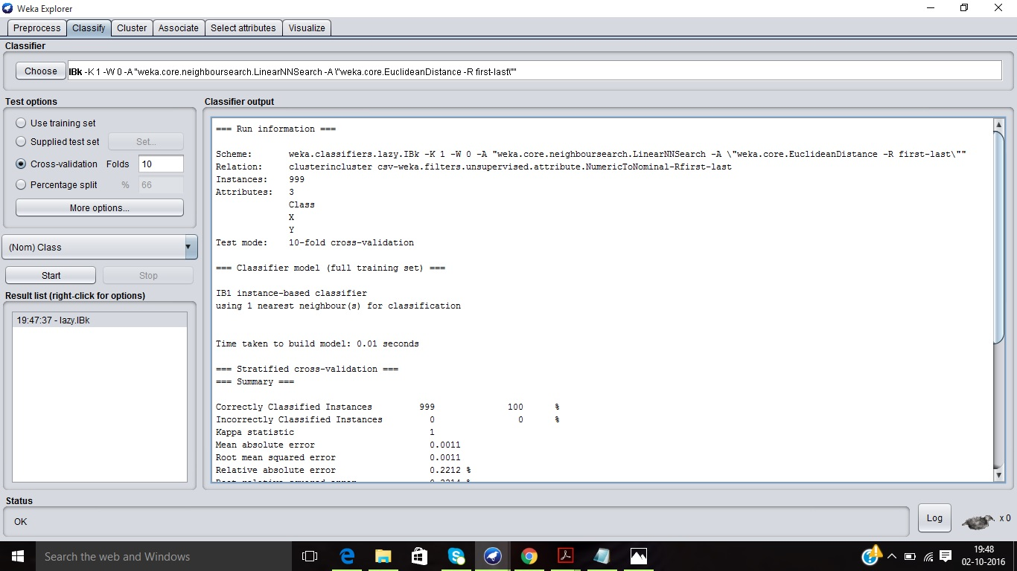

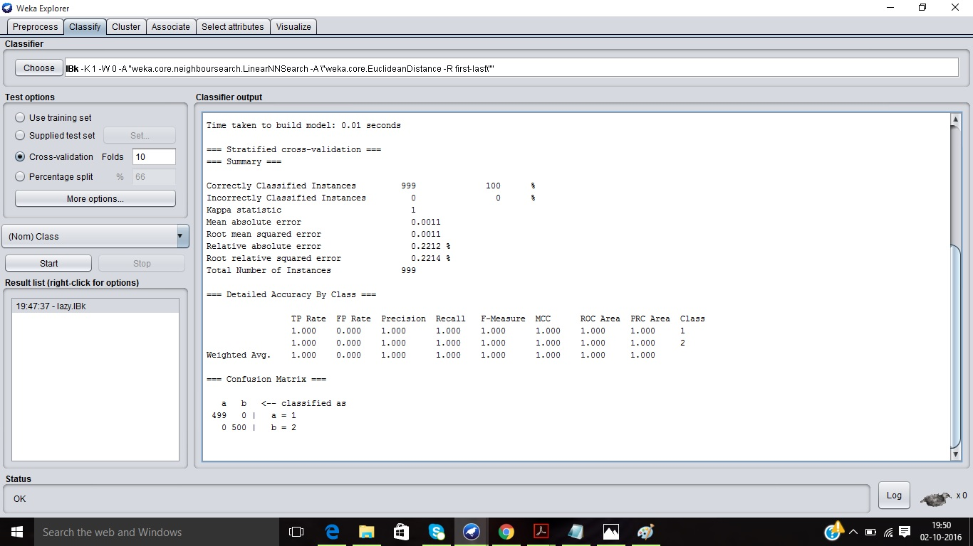

Screenshot: For K=1, Visualizing the threshold curve for Class 1

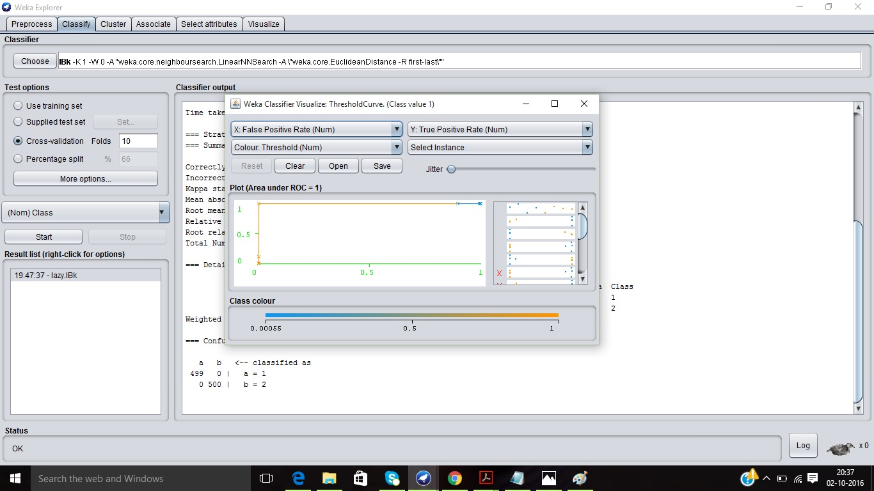

Screenshot: For K=1, Visualizing the threshold curve for Class 2

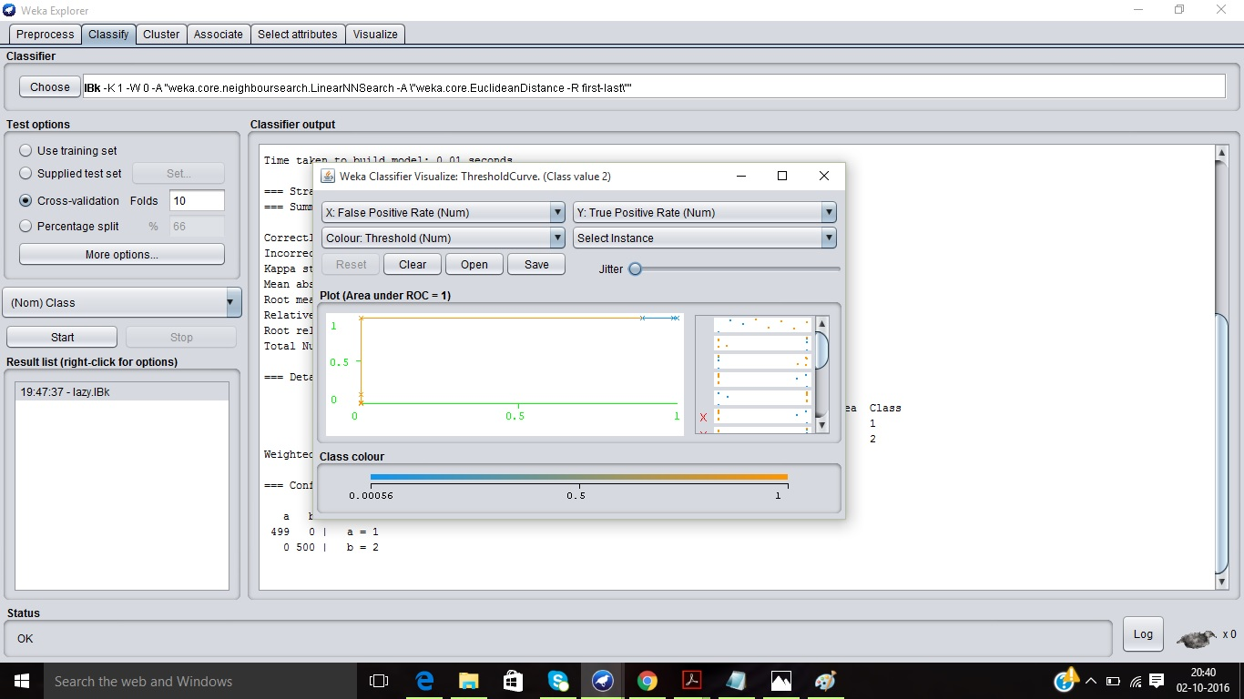

HALFKERNEL dataset

Screenshot: When K=1, Accuracy is 100%

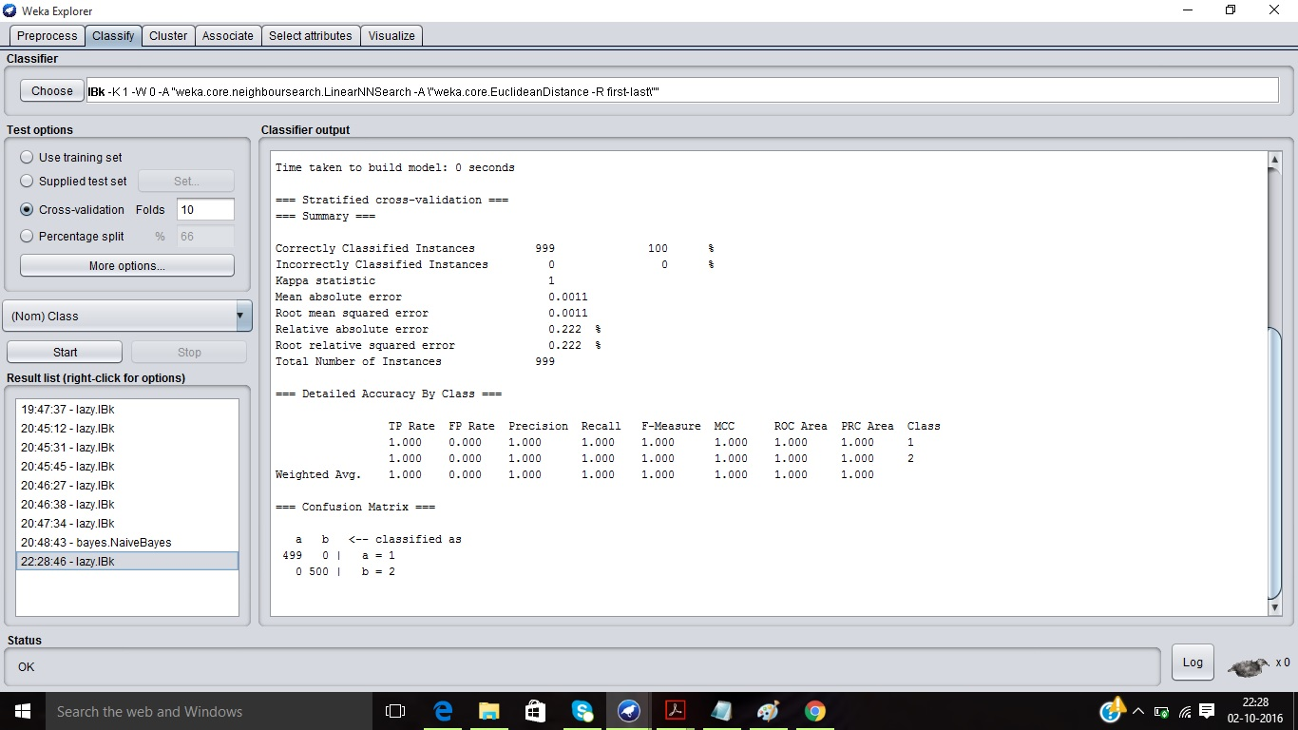

Screenshot: For K=1, Visualizing the threshold curve for Class 1

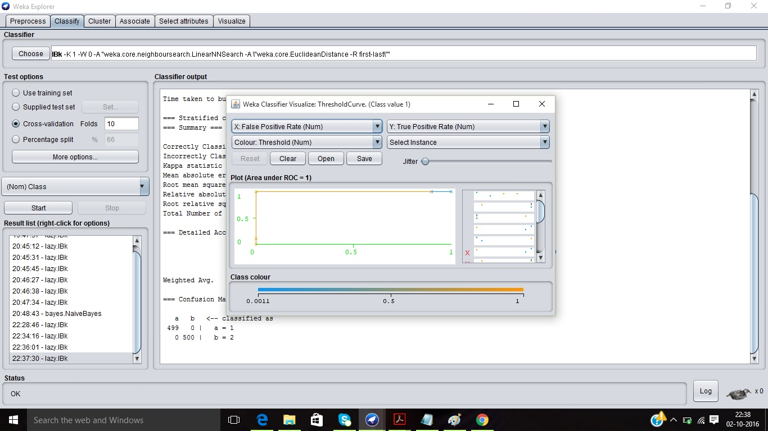

Screenshot: For K=1, Visualizing the threshold curve for Class 2

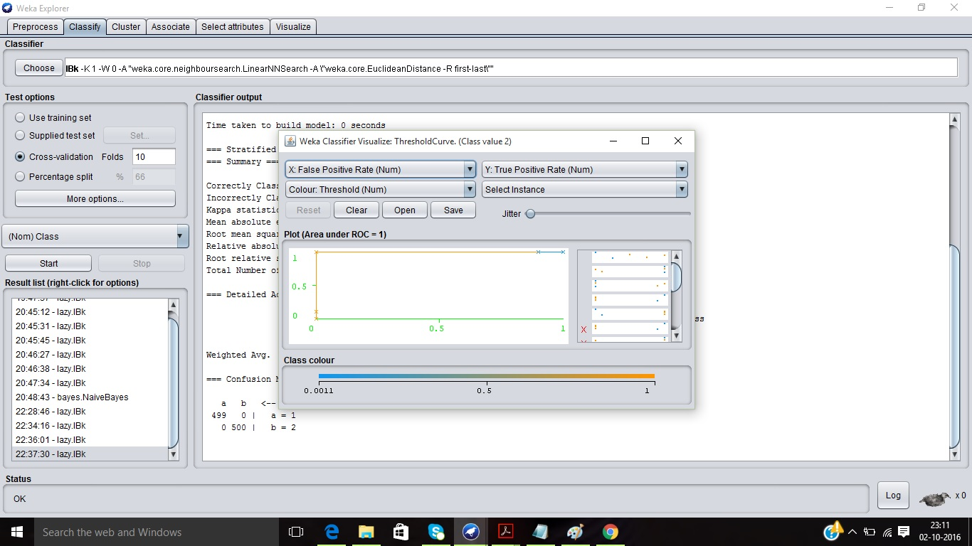

TWO GAUSSIANS dataset

Screenshot: When K=1, Accuracy is 95.99%

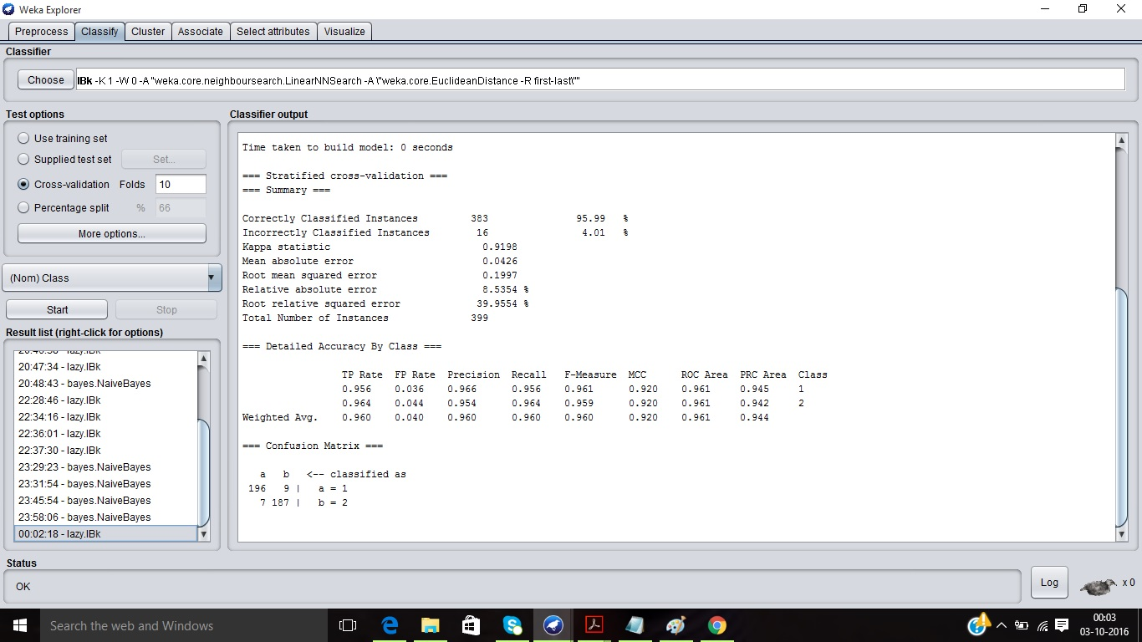

Screenshot: For K=1, Visualizing the threshold curve for Class 1

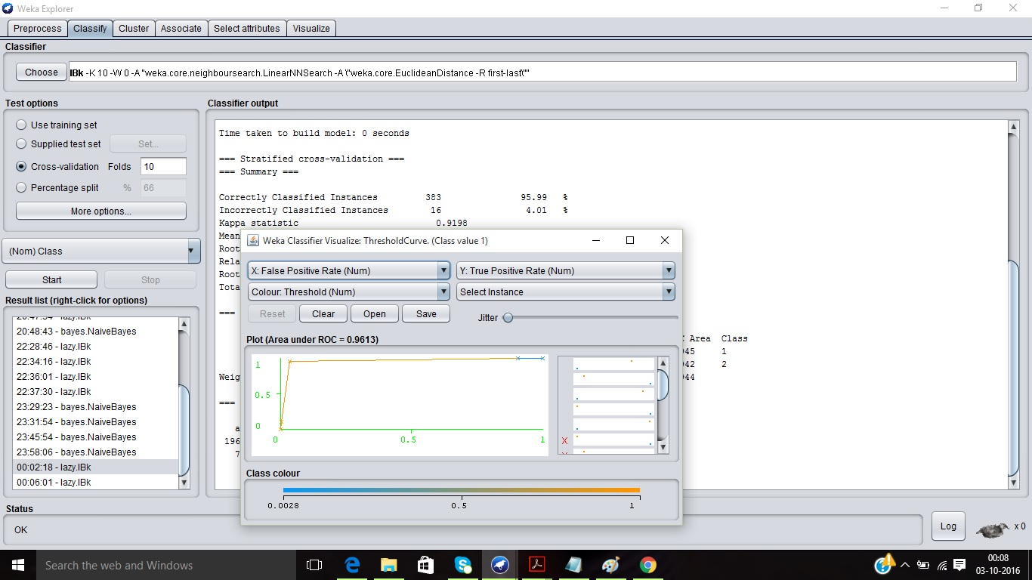

Screenshot: For K=1, Visualizing the threshold curve for Class 2

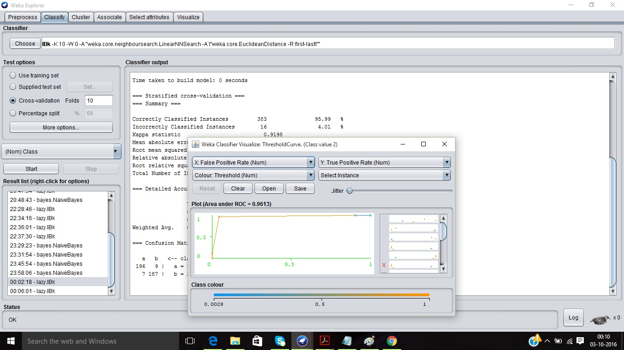

TWO SPIRALS dataset

Screenshot: When K=1, Accuracy is 94.49%

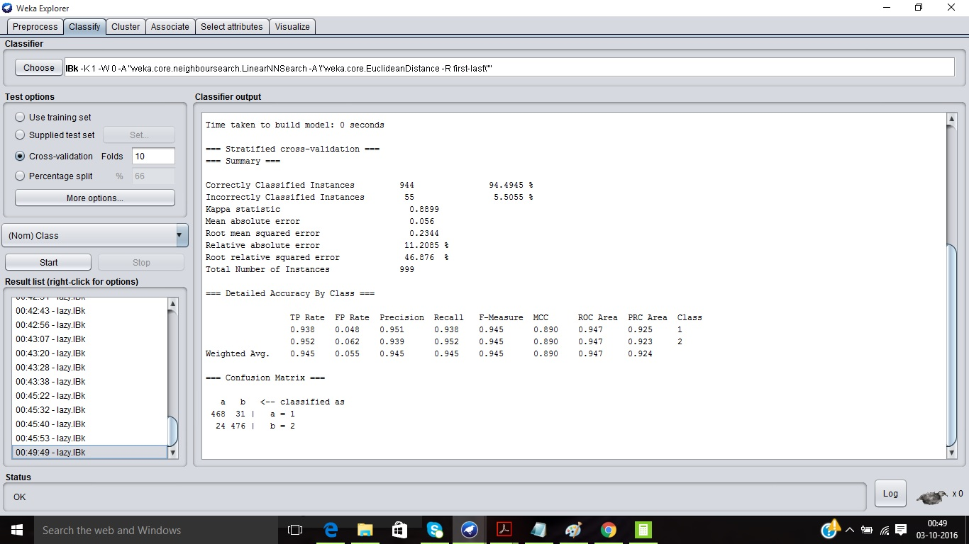

Screenshot: For K=1, Visualizing the threshold curve for Class 1

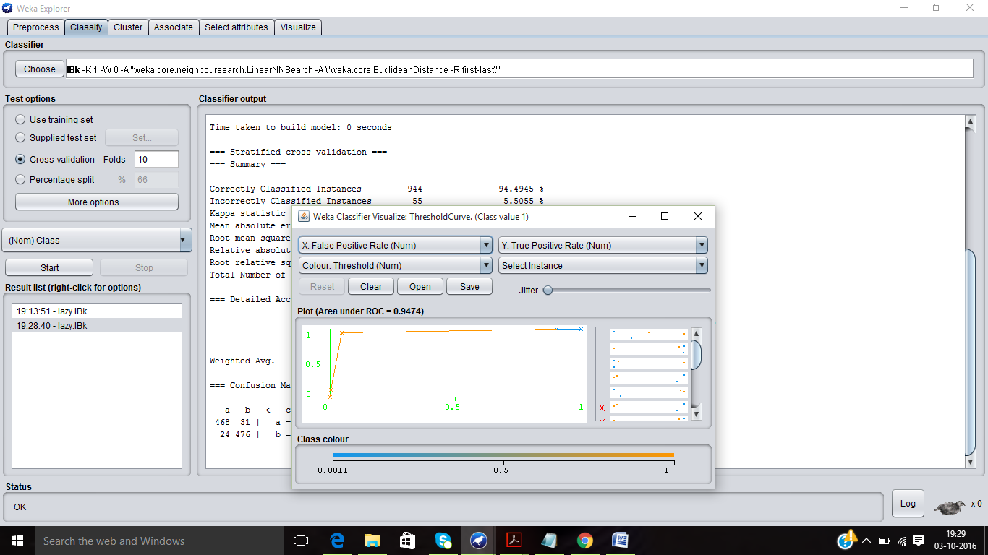

Screenshot: For K=1, Visualizing the threshold curve for Class 2

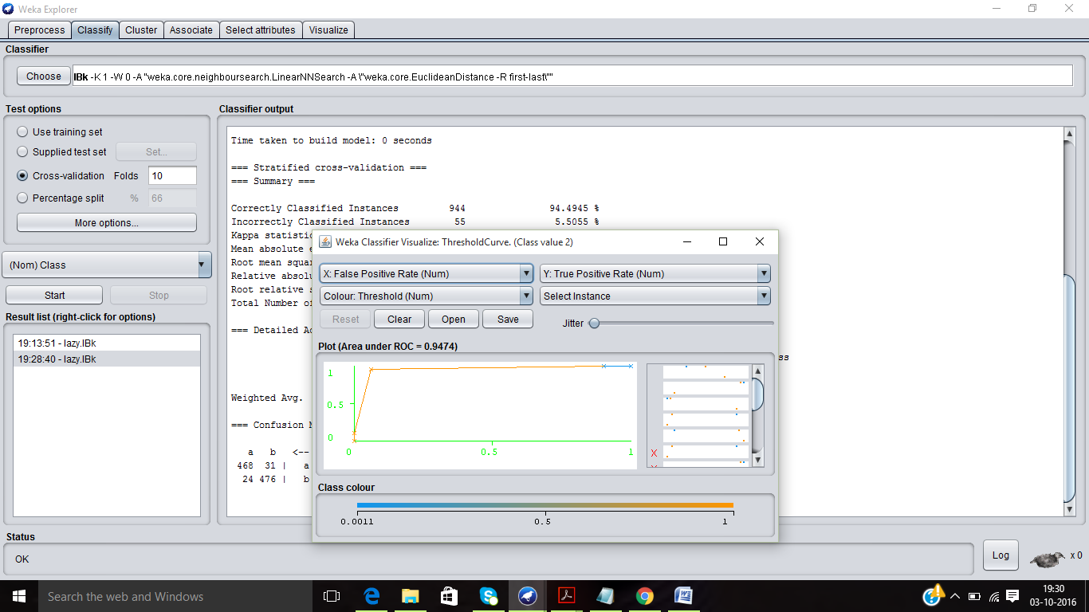

1. **B) NAIVE BAYES Classifier**

When the relationships among the features are unknown, the features are conditionally independent in that category.

It used for classifying all the real world problems by using the probability function given by-

Assume, X1, X2 ....Xd are independentthen,

P(x/wj)= where j=1,2 .. c

Simple Naive Bayes classifier is based on normal distributions.

For the minimum error-rate case, gi(x) = P(ωi|x).

CLUSTERINCLUSTER dataset

Screenshot: Simple Naive Bayes Classifier with default parameters, Accuracy is 99.89%

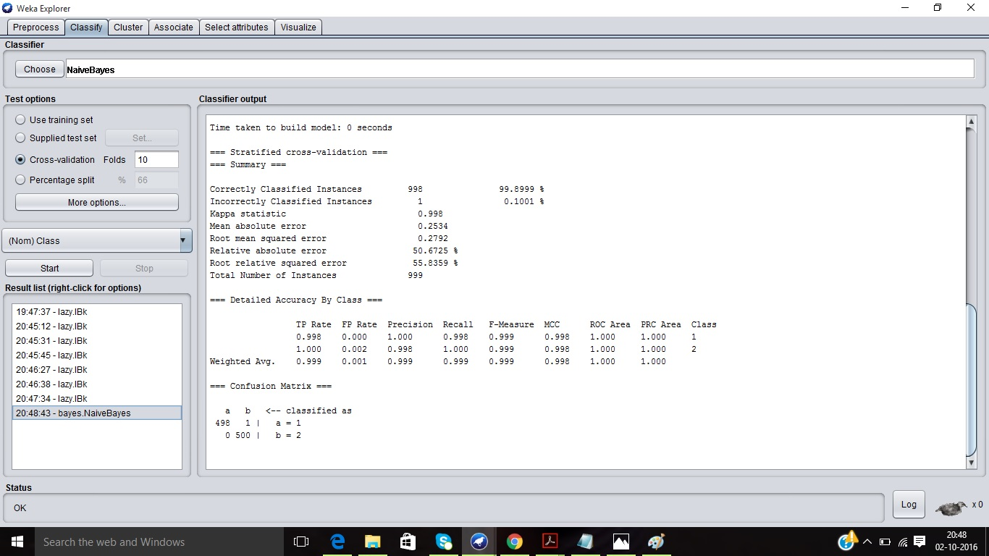

HALFKERNEL dataset

Screenshot: Simple Naive Bayes Classifier with default parameters, Accuracy is 94.09%

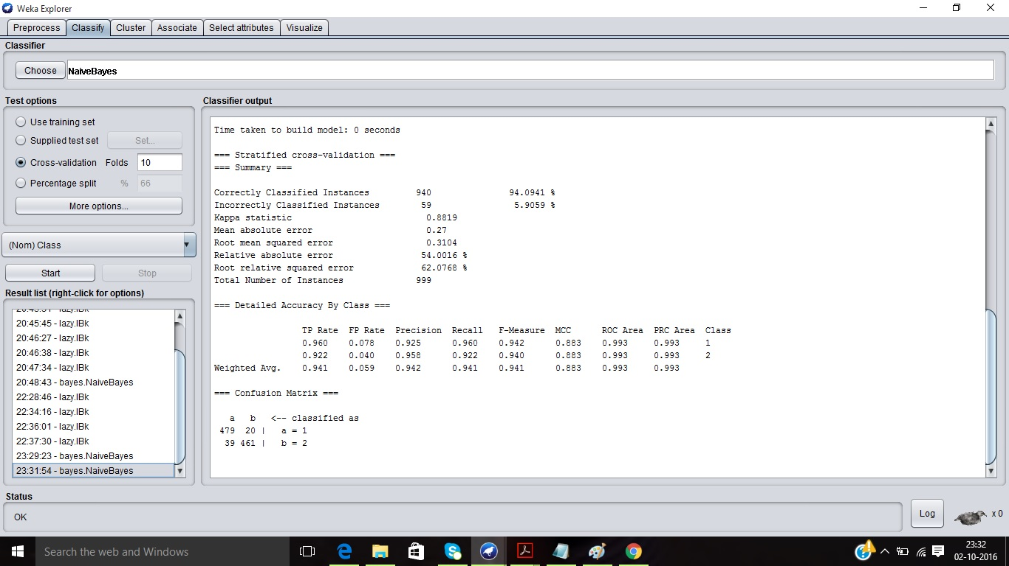

TWO GAUSSIANS dataset

Screenshot: Simple Naive Bayes Classifier with default parameters, Accuracy is 96.74%

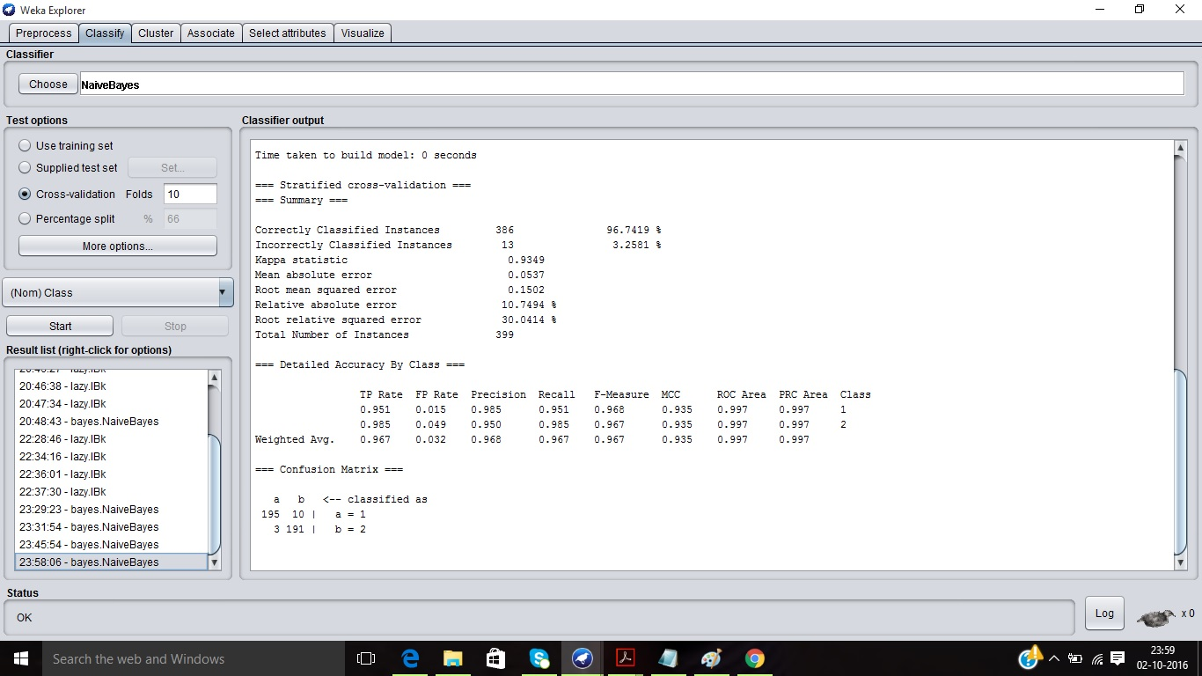

TWO SPIRALS dataset

Screenshot: Simple Naive Bayes Classifier with default parameters, Accuracy is 63.86%

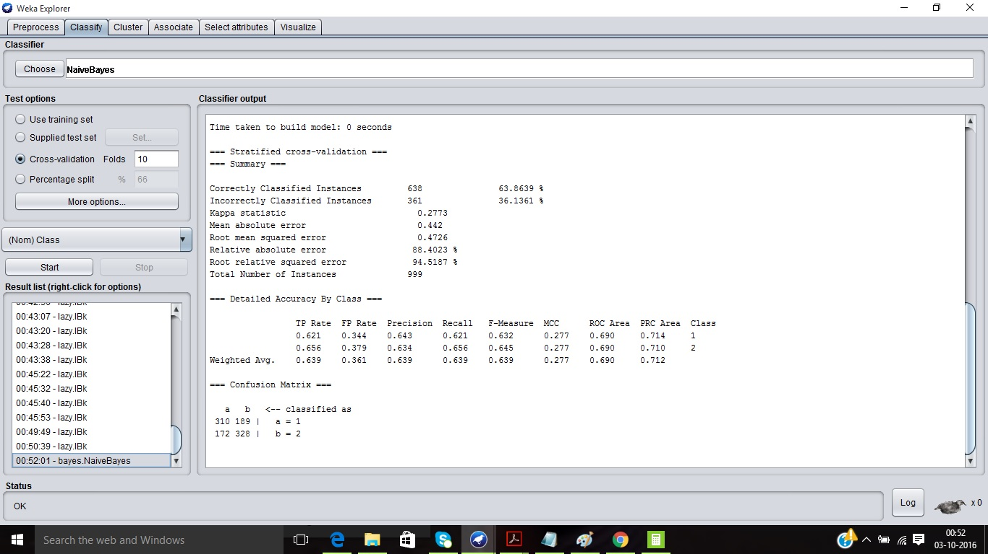

1. C) **Specifying how to classify for one dataset-**

Pre-processing is required on the raw dataset to start classification is Weka. The given .dat format is either converted to .csv or .arff format or then opened in Weka. Weka easily recognises the ARFF format.

The class samples must be filtered by selecting ‘filters’, expanding unsupervised column and then selecting ‘attributes’. The class samples must be converted to Nominal for classification chooses ‘NumericToNominal’ conversion. Although, the individual class values must be numeric. Click on the ‘Visualize all’ button to view the samples corresponding to each class.

In the Classify tab, from the ‘Choose’ button select classifiers like Naive Bayes, IBk etc and apply the filters. The parameters for these filters can also be changed correspondingly. In the test options, use training or test datasets and also vary the cross validation value. By pressing the Start button, it classifies the class samples and produces the result.

Each classification method can be visualised for its threshold curve values by right clicking on the classifier which ran and then selecting the required class ( e.g.: Threshold curve for Class 1 or 2).

In Visualize tab, the points are plotted in the 2D space which can be viewed near the plot matrix (values of X and Y). PlotSize and PointSize can be altered for better display. Select the corresponding class for display and their colour can also be modified as required.

CLUSTERINCLUSTER dataset

Screenshot: Before Classifying ( Opening the dataset in Weka and visualising all the samples)

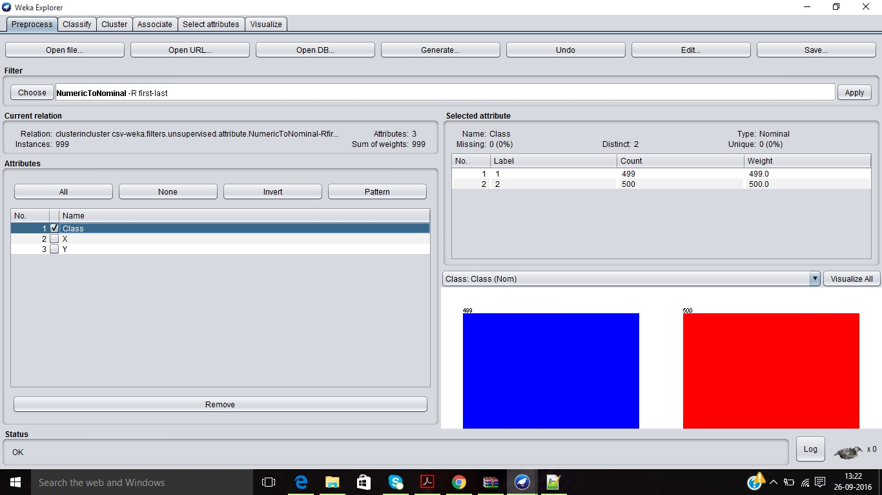

Screenshot: After Classifying (Using Naive Bayes)

Screenshot: After Classifying (Using K-NN Classifier with K=10)

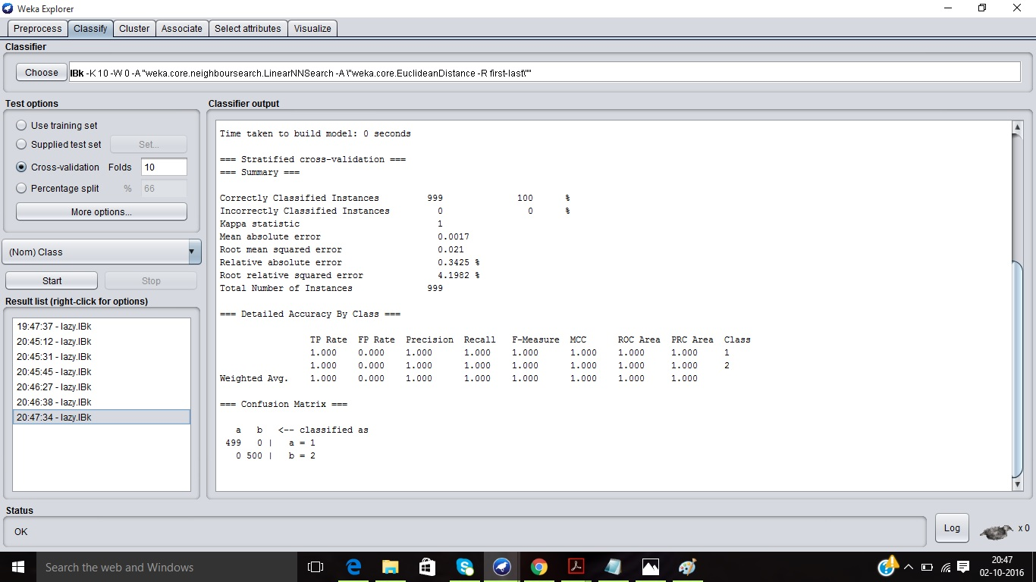

1. **Two Classification methods using 10-fold cross validation**

CROSS VALIDATION-

In cross validation, datasets are randomly split into training dataset and validation dataset (testing dataset). To reduce the generalisation error, the classifier is trained until it reaches a minimum of this validation error.

Given a dataset, D=D1 U D2 U D3 ... U Dc and Di is split into two subsets Di1 and Di2.

Then, training dataset is D11 U D21 ... U Dc1

Testing dataset is D12 U D22 U ... Dc2

A generalisation of this method is the M-FOLD CROSS VALIDATION. The datasets are divided into m disjoint sets of equal size and trained m times. Every time validation happens, one different set in used for testing and remaining samples are used for training. We can repeat the process, by swapping the training and testing sets. The estimated performance is the mean of these m errors.

10 FOLD CROSS VALIDATION-

The first 90% of the patterns is used as a standard training set for setting free parameters in the classifier model and the other 10% is the validation set and is meant to represent the full generalization task. In Weka, the m value can be adjusted to perform validation. Counters are used to run for 10 iterations and the total number of TN (True Negatives), TP (True Positives), FN (False Negatives) and FP (False Positives). The total number of samples n is given by the summation of all the parameters.

The performance metrics for the two classes assuming one to be positive and negative are given by the following formulae-

* **TP rate= $\frac{TP}{TP+FN}=\frac{TP}{P}$ FP rate = $\frac{FP}{TN+FP}$** = $\frac{FP}{N}$
* **PPV= $\frac{TP}{TP+FP}$ NPV= $\frac{TN}{TN+FN}$**
* **Specificity= $\frac{TN}{TN+FP}$ = 1-FP rate Sensitivity= $\frac{TP}{TP+FN}$ =TP rate**
* **Accuracy= $\frac{TP+TN}{n}$,** where n is the total number of samples
* **Geometric Mean = $\sqrt{SE*SP}$**
* **n=TP+FN+FP+TN**
* **Error rate= $\frac{FP+FN}{n}$ =1-Accuracy**

|  |
| --- |
|  |

Naive BAYES Classifier

1. CLUSTER IN CLUSTER DATASET-

The total no of samples in this dataset is n=498+1+0+500=999

TP rate = $\frac{498}{498+1}$ =0.99 FP rate= $\frac{0}{500+0}$ =0.00

PPV = $\frac{498}{498+0}$ =1 NPV= $\frac{500}{1+500}$ =0.998

Specificity= 1- 0=1 Sensitivity=0.99

Geometric Mean= $\sqrt{1*0.99}$ =0.994

Accuracy= $\frac{498+500}{999}$ =0.998=99.8% Error rate= 1-0.998=0.002=0.2%

Screenshot: All the efficiency measures are calculated in Weka



1. HALF KERNEL DATASET-

The total no of samples in this dataset is n=498+1+0+500=999

TP rate = $\frac{479}{479+20}$ =0.9599 FP rate= $\frac{39}{39+461}$ =0.078

PPV = $\frac{479}{479+39}$ =0.924 NPV= $\frac{39}{39+461}$ =0.078

Specificity= 1- 0.078=0.922 Sensitivity=0.9599

Geometric Mean= $\sqrt{0.922*0.9599}$ =0.940

Accuracy= $\frac{479+461}{999}$ =0.940=94.0% Error rate= 1-0.940=0.06=6%

Screenshot: All the efficiency measures are calculated in Weka for half kernel



1. TWO GAUSSIANS DATASET-

The total no of samples in this dataset is n=196+9+7+187=399

TP rate = $\frac{195}{195+10}$ =0.951 FP rate= $\frac{3}{10+3}$ =0.23

PPV = $\frac{195}{195+3}$ =0.98 NPV= $\frac{191}{191+10}$ =0.95

Specificity= 0.98 Sensitivity=0.95

Geometric Mean= $\sqrt{0.98*0.95}$ =0.964

Accuracy= $\frac{195+191}{399}$ =0.967=96.7% Error rate= 1-0.967=0.033=3.3%

Screenshot: All the efficiency measures are calculated in Weka for half kernel



1. TWO SPIRAL DATASET-

The total no of samples in this dataset is n=498+1+0+500=999

TP rate = $\frac{310}{310+189}$ =0.621 FP rate= $\frac{172}{328+172}$ =0.344

PPV = $\frac{310}{310+172}$ =0.643 NPV= $\frac{328}{328+189}$ =0.634

Specificity= 1- 0.344=0.656 Sensitivity=0.621

Geometric Mean= $\sqrt{0.621*0.656}$ =0.638

Accuracy= $\frac{310+328}{999}$ =0.638=63.8% Error rate= 1-0.638=0.361=36.1%

Screenshot: All the efficiency measures are calculated in Weka for two spirals



K-NN Classifier

1. CLUSTER IN CLUSTER DATASET-

The total no of samples in this dataset is n=498+1+0+500=999

TP rate = $\frac{499}{499+0}$ =1 FP rate= $\frac{0}{500+0}$ =0.00

PPV = $\frac{499}{499+0}$ =1 NPV= $\frac{500}{0+500}$ =1

Specificity= 1- 0=1 Sensitivity=1

Geometric Mean= $\sqrt{1*1}$ =1

Accuracy= $\frac{499+500}{999}$ =1=100% Error rate= 1-1=0=0%

Screenshot: All the efficiency measures are calculated in Weka for Cluster in Cluster

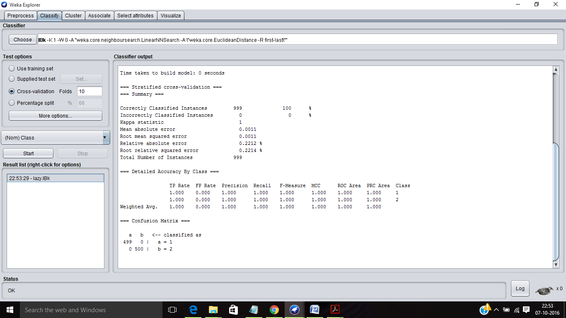

1. HALF KERNEL DATASET-

The total no of samples in this dataset is n=498+1+0+500=999

TP rate = $\frac{499}{499+0}$ =1 FP rate= $\frac{0}{500+0}$ =0.00

PPV = $\frac{499}{499+0}$ =1 NPV= $\frac{500}{0+500}$ =1

Specificity= 1- 0=1 Sensitivity=1

Geometric Mean= $\sqrt{1*1}$ =1

Accuracy= $\frac{499+500}{999}$ =1=100% Error rate= 1-1=0=0%

Screenshot: All the efficiency measures are calculated in Weka for Half Kernel



1. TWO GAUSSIANS DATASET-

The total no of samples in this dataset is n=196+9+7+187=399

TP rate = $\frac{196}{196+9}$ =0.956 FP rate= $\frac{7}{187+7}$ =0.036

PPV = $\frac{196}{196+7}$ =0.965 NPV= $\frac{187}{187+9}$ =0.954

Specificity= 1- 0.036=0.963 Sensitivity=0.956

Geometric Mean= $\sqrt{0.963*0.956}$ =0.960

Accuracy= $\frac{196+187}{399}$ =0.959=95.9% Error rate= 1-0.959=0.041=4.1%

Screenshot: All the efficiency measures are calculated in Weka for Two Gaussians



1. TWO SPIRAL DATASET-

The total no of samples in this dataset is n=498+1+0+500=999

TP rate = $\frac{468}{468+31}$ =0.937 FP rate= $\frac{24}{24+476}$ =0.048

PPV = $\frac{468}{468+24}$ =0.951 NPV= $\frac{476}{476+31}$ =0.938

Specificity= 1- 0.048=0.952 Sensitivity=0.937

Geometric Mean= $\sqrt{0.952*0.937}$ =0.994

Accuracy= $\frac{468+476}{999}$ =0.944=94.4% Error rate= 1-0.944=0.056=5.6%

Screenshot: All the efficiency measures are calculated in Weka for Two Spirals



1. **Results of Each Classifier for all datasets**

The threshold curves for various classes and the visualisation of the datasets screenshots are present under Question 1. The results of various datasets for each classifier is as follows-

Naive Bayes Classifier

1. Cluster In Cluster Dataset



1. Half Kernel Dataset-



1. Two Gaussians Dataset-



1. Two Spiral Dataset-



K-NN Classifier

1. Cluster In Cluster Dataset

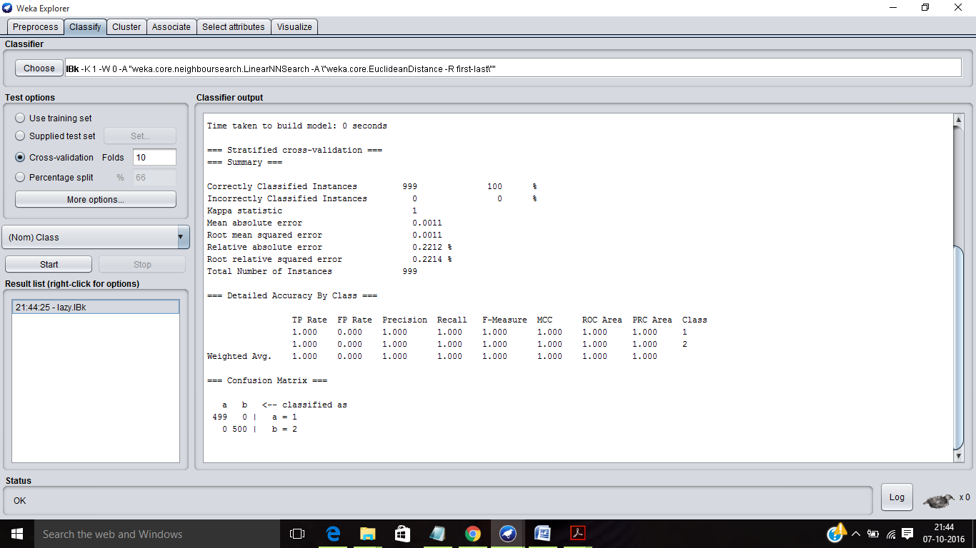

1. Half Kernel Dataset

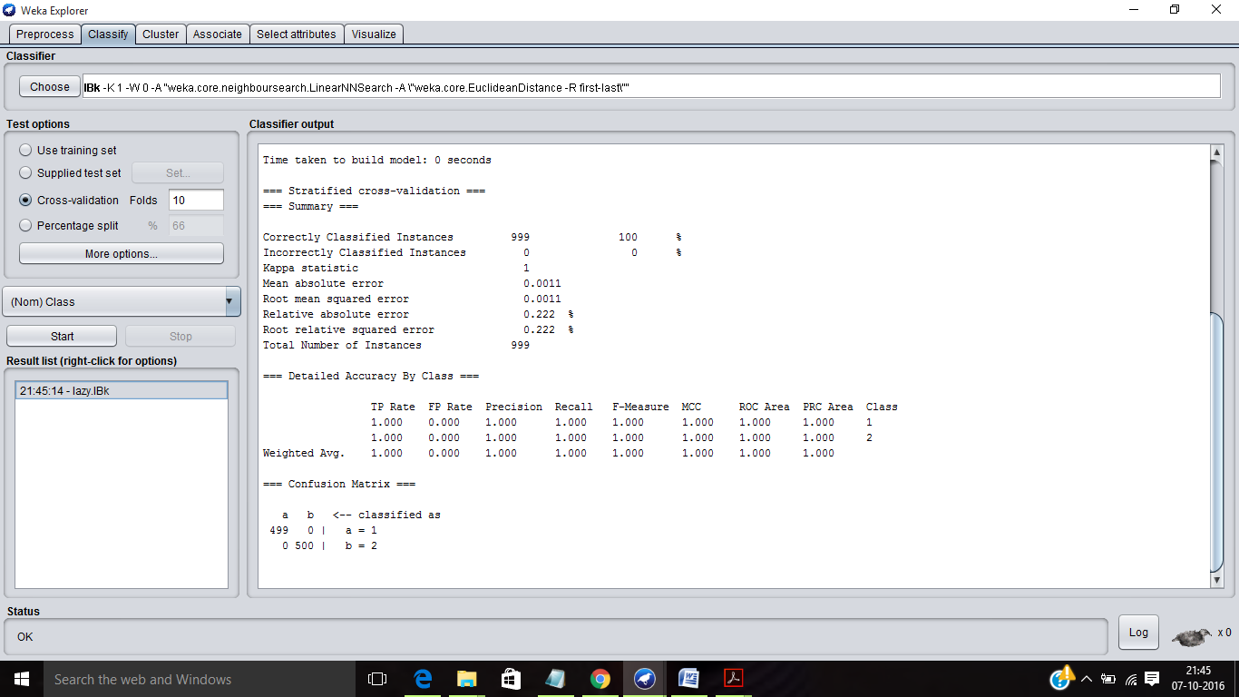

1. Two Gaussians Dataset

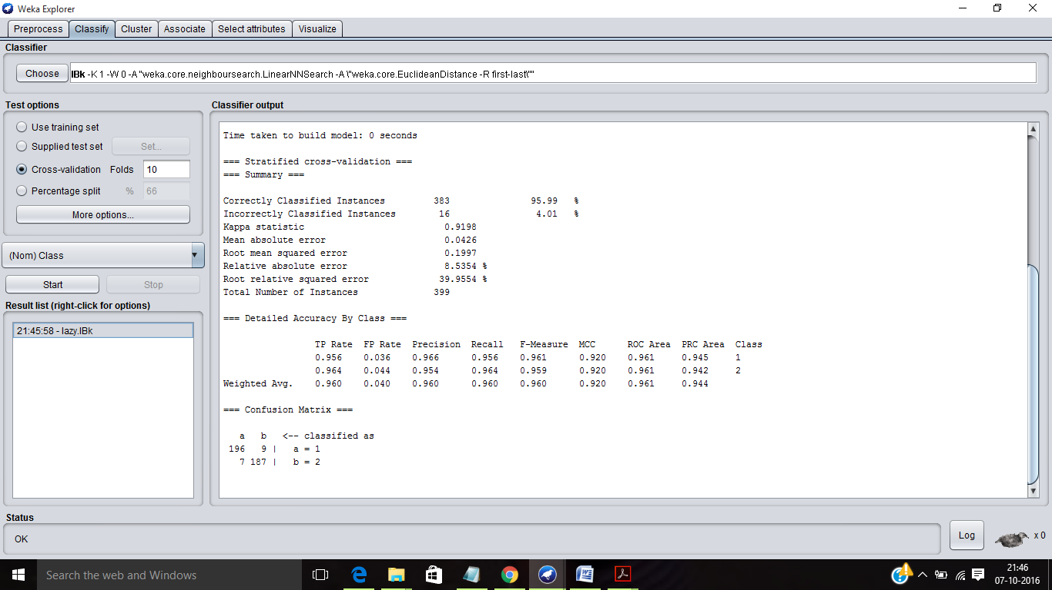

1. Two Spirals Dataset

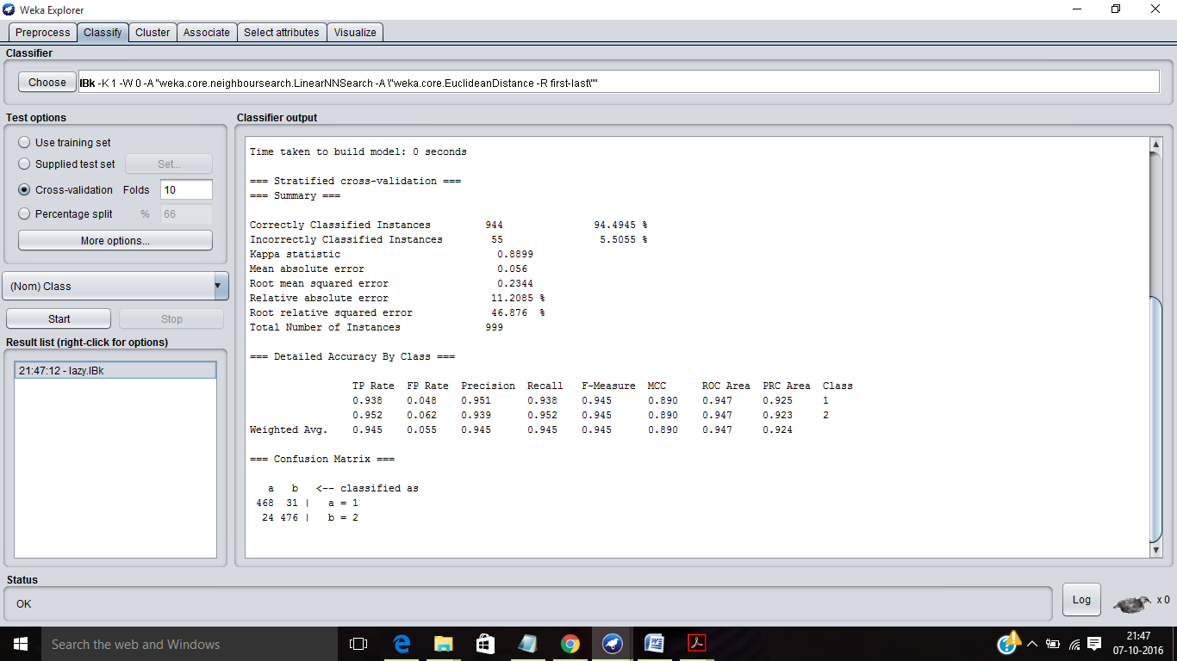

**4) Best Value of K in K-NN Classifier and Comparison with 1-NN and Naive Bayes Classifier**

K-Nearest Neighbour estimation method allows finding the probability of x given a number of prototypes. Start the empty region such that R ≡x and grow it until it captures k samples.

Let D={X1, X2, ... Xn} be labelled training samples or prototypes. Then, x € wj (a class).

Region grows until all k nearest neighbours samples are covered where k1 samples w1, k2 samples w2, ... kc samples wc and kj is the max of k1, k2, .. kc.

1-NN rule: For the unknown sample x, decide on the class of sample x’ that is closest to x, which makes K=1.

BEST VALUE OF K:

k= $\sqrt{n}$ where n is the total number of samples and k is the parameter for K-NN classifier.

The closeness between the samples is measured by calculating the distance between the two samples (metric).

The best value of k for the 4 datasets is as follows-

1. Cluster in Cluster Classifier-

When k=1-3, 8-32 Accuracy=100%

When k=4-8 Accuracy=99.89%

1. Half Kernel Classifier-

When K=1-32, Accuracy is 100%

1. Two Gaussians Classifier-

When k=1 Accuracy= 95.99%

When k=10 Accuracy= 97.2431% When k=20 Accuracy= 95.99%

1. Two Spirals Classifier-

When K=1, Accuracy is 94.4945%

When k=32 Accuracy= 93.693% When k=20 Accuracy= 96.1962%

For Naive Bayes Classifier, the accuracy is as follows-

1. Cluster in Cluster Classifier-

Accuracy is 99.89%

1. Half Kernel Classifier-

Accuracy is 94.6947%

1. Two Gaussians Classifier-

Accuracy is 96.7419%

1. Two Spirals Classifier-

Accuracy is 63.8639%

Calculations and Screenshots are present as part of Question 2 and 7.

**5) ROC Curves for one classifier (Naives Bayes Classifier)**

An ROC graph is actually two-dimensional graph in which True Positive Rate (TPR) is plotted on the Y axis and False Positive Rate (FPR) is plotted on the X axis. ROC performance of a classifier is usually represented by a value which is the area under the ROC curve (AUC).

In Weka, after running the classifier for each dataset, choose ‘Visualize threshold curve’ and select 1 or 2 based on the class.

The points obtained are connected using cut off levels which forms the convex skull.

CLUSTER IN CLUSTER DATASET

Screenshot: Naive Bayes Classifier, Visualizing the threshold curve for Class 1

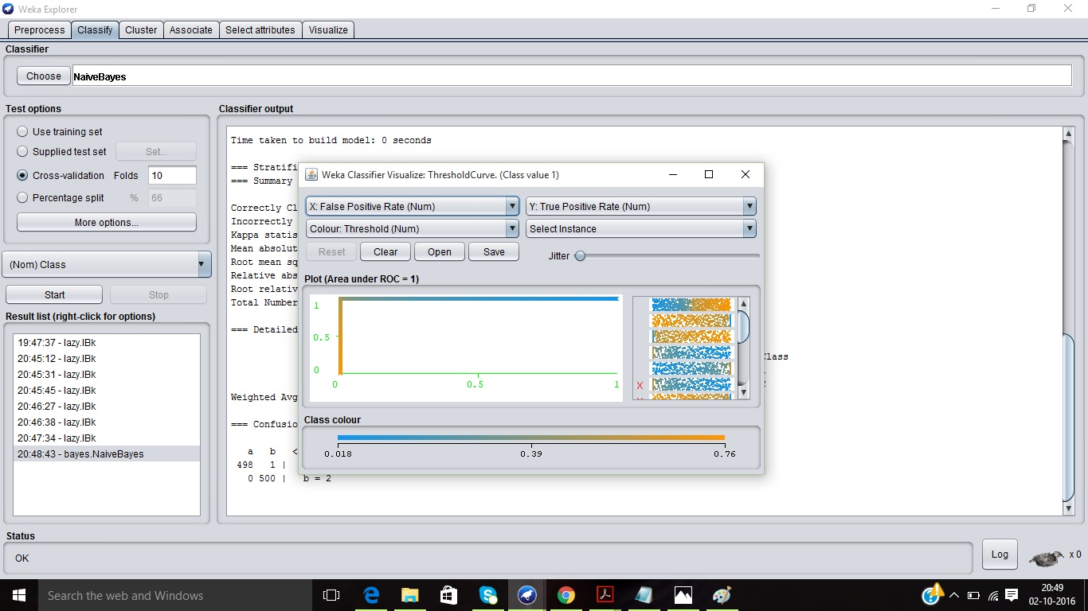

Screenshot: Naive Bayes Classifier, Visualizing the threshold curve for Class 1

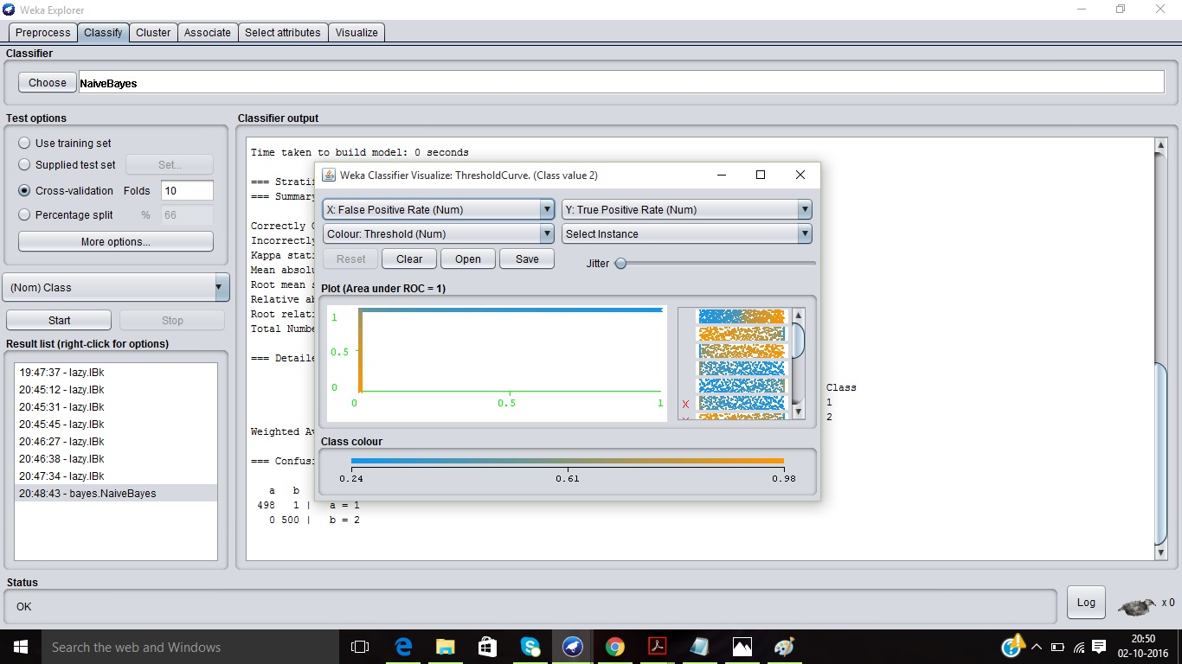

HALFKERNEL dataset

Screenshot: Naive Bayes Classifier, Visualizing the threshold curve for Class 1

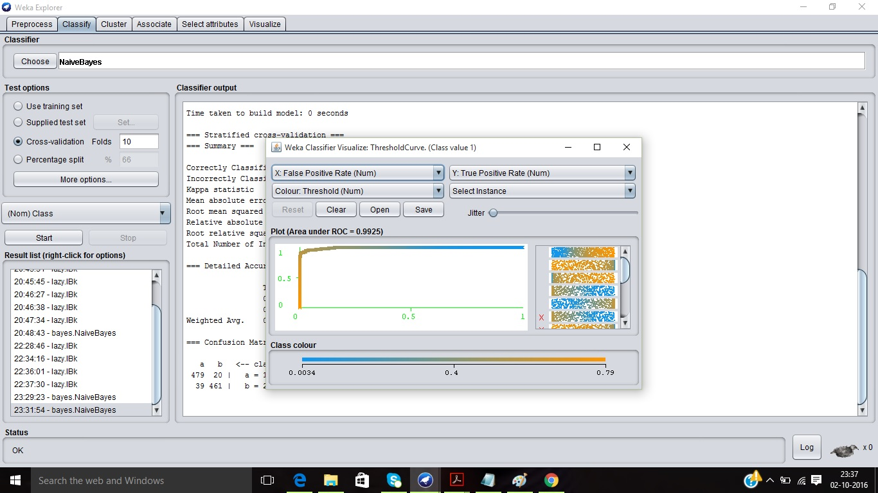

Screenshot: Naive Bayes Classifier, Visualizing the threshold curve for Class 2

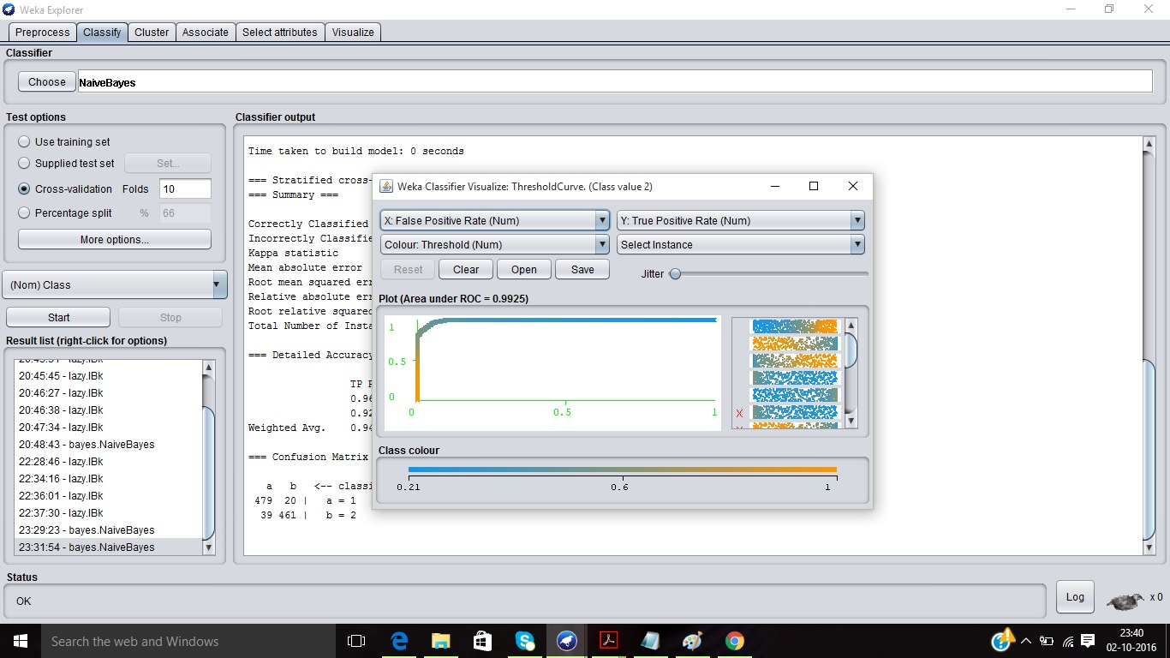

TWO GAUSSIANS dataset

Screenshot: Naive Bayes Classifier, Visualizing the threshold curve for Class 1

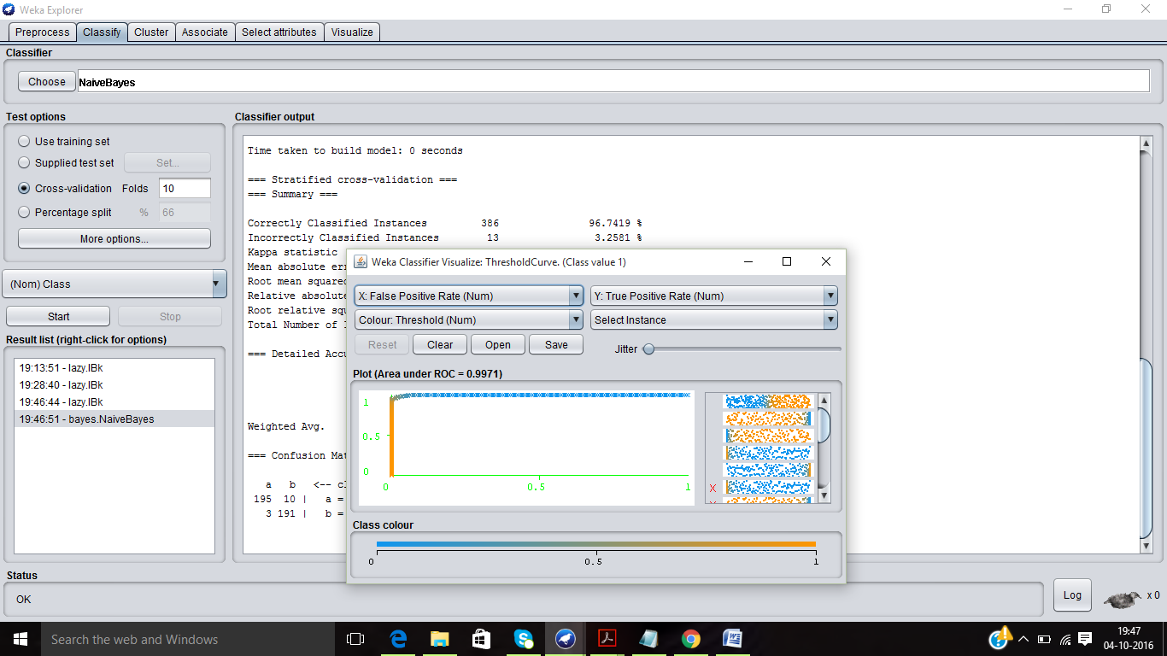

Screenshot: Naive Bayes Classifier, Visualizing the threshold curve for Class 2

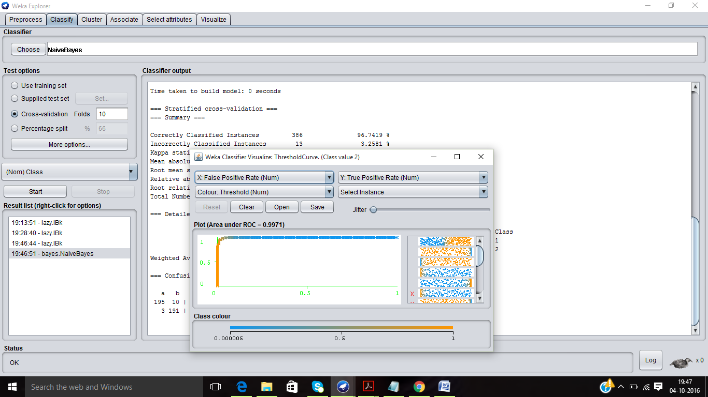

TWO SPIRALS DATASET

Screenshot: Naive Bayes Classifier, Visualizing the threshold curve for Class 1

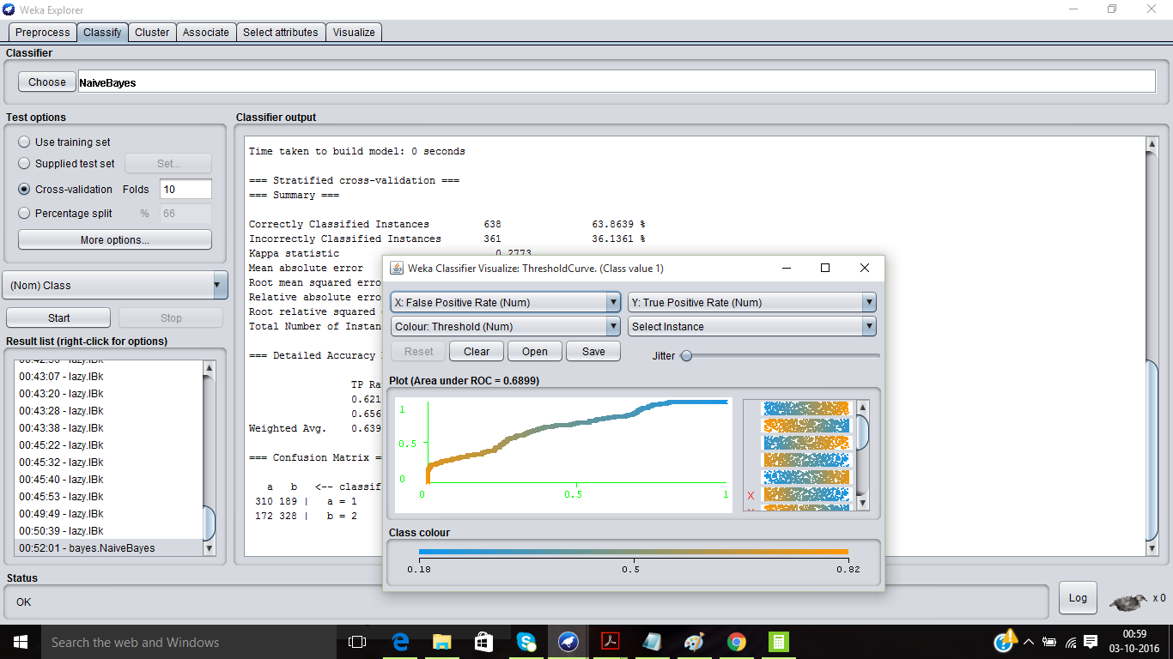

Screenshot: Naive Bayes Classifier, Visualizing the threshold curve for Class 2

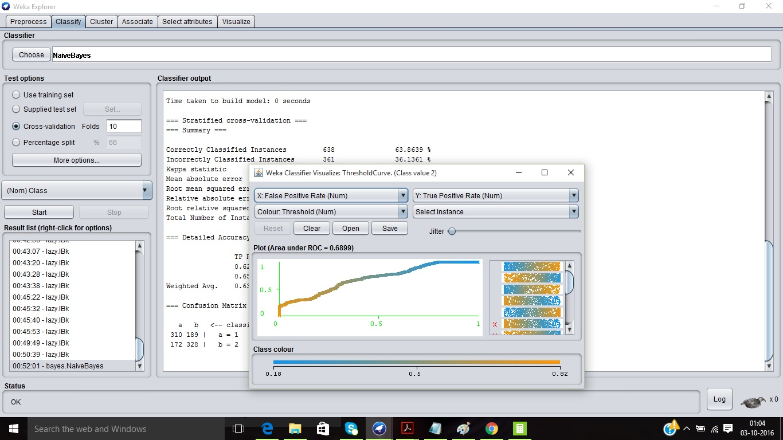

**6) Plotting the samples in 2D space**

The visualize tab has the matrix panel where the points are plotted in 2D space against the X and Y axis. The plot matrix shows the shape of the samples for each dataset.

PlotSize is used to increase the size of the matrix panel and PointSize is used to increase the size of individual sample points. Jitter is used to add any noise if required. The class can be chosen for display through select attributes button. The colour of the samples can also be altered and finally after pressing Update button, the changes take place.

1. Cluster In Cluster Dataset-

Screenshot: Classes 1 and 2 samples are visualised in red and blue colour respectively

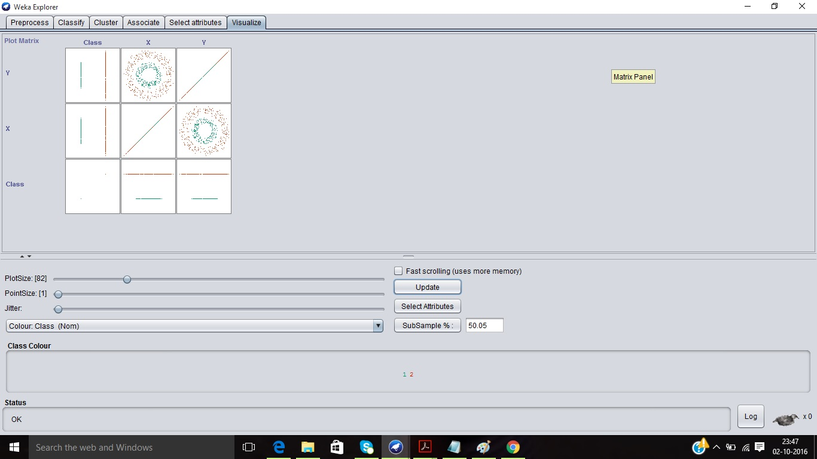

Screenshot: Change Select Instance to Rectangle

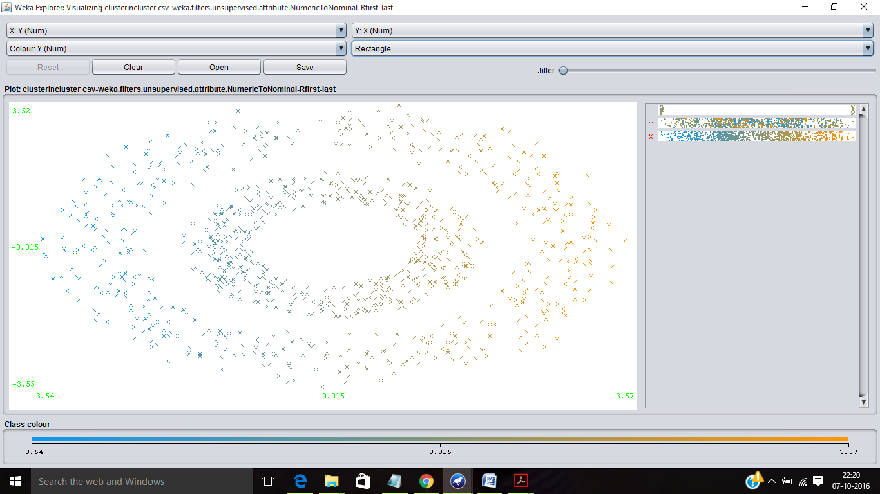

The number of attributes to be displayed in the graph can be changed from the select attributes button.

1. Half Kernel Dataset-

Screenshot: The points are plotted which visualizes being a parabola.

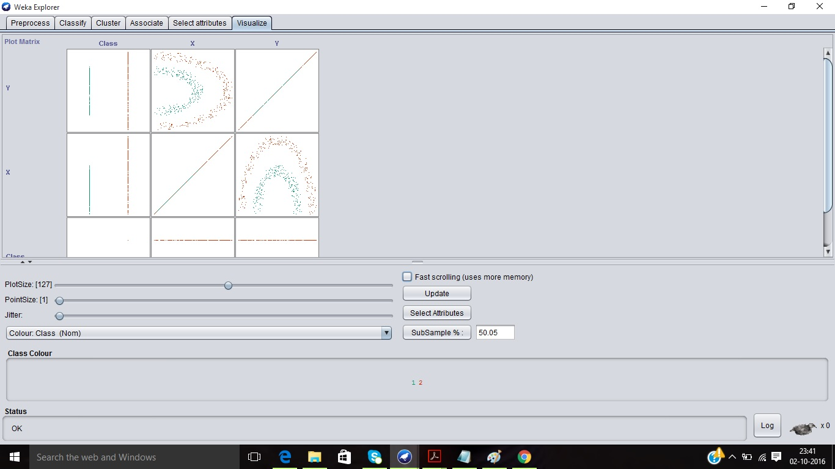

Jitter must be as minimum as possible as it adds noise to the visualisation of the two class samples.

1. Two Gaussians Dataset-

Screenshot: Point Size is increased to a value of 2 to enhance the display

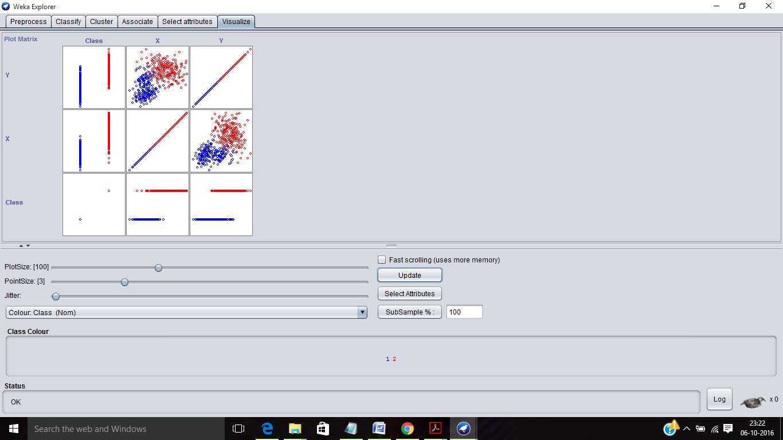

1. Two Spiral Dataset-

Screenshot: Class 1 colour is changed to white displaying Class 2 samples in a spiral fashion

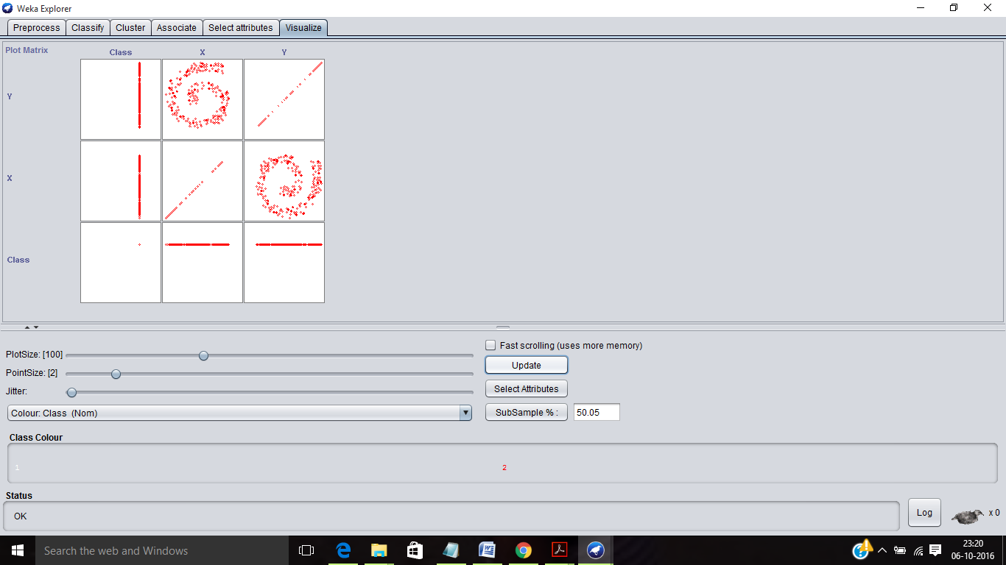

Screenshot: Class 2 colour is changed to white displaying Class 1 samples in a spiral fashion

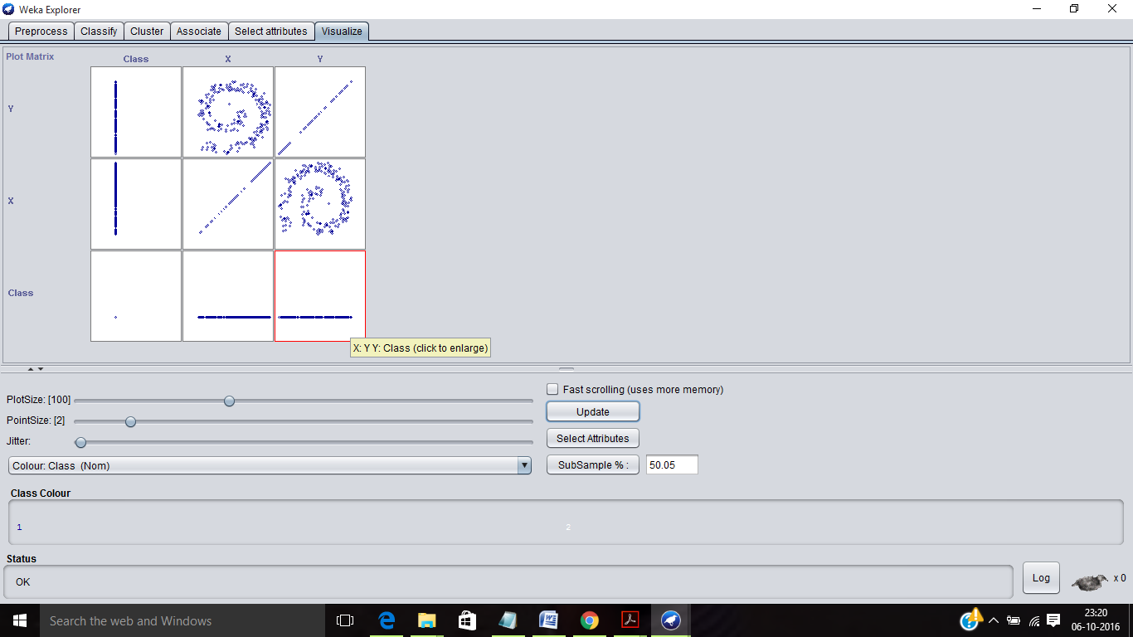

Screenshot: Classes 1 and 2 are visualised spirally

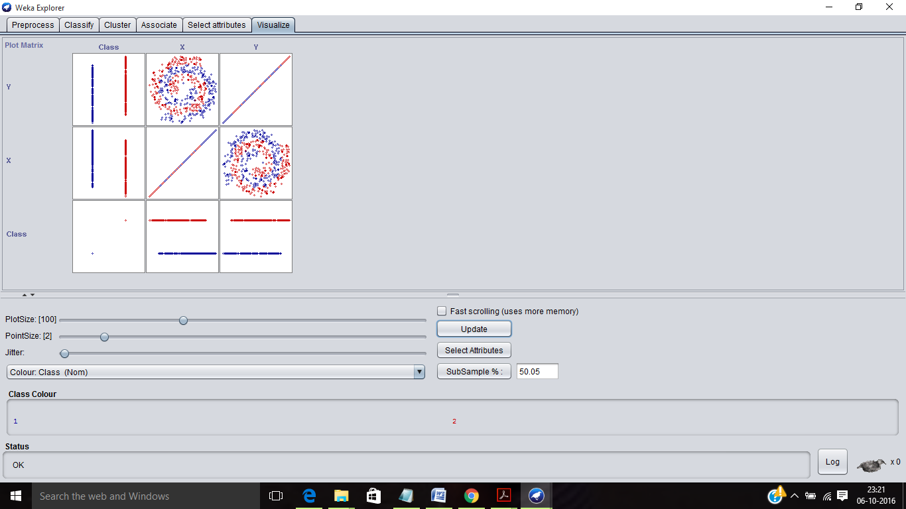

**7) a) Behaviours of Classifiers**

NAIVE BAYES CLASSIFIER

Naive Bayesian classifiers assume that there are no dependencies amongst attributes. This assumption is called class conditional independence. It is made to simplify the computations involved and, hence is called Naive. This classifier is also called idiot Bayes, simple Bayes, or independent Bayes.

Pros: They do not have many parameters to be set. The classifier returns probabilities hence it is easier to apply these results. They are computationally fast when making decisions and do not require large amounts of data before learning can begin.

Cons: NB should not be used if the data is not having conditional independence and if the decision boundary is not linear.

K-NN CLASSIFIER

The k-nearest neighbour algorithm (k-NN) is a method to classify an object based on the majority class amongst its k nearest neighbours. The k-NN is a type of lazy learning where the function is only approximated locally and all computation is deferred until classification.

k-NN algorithm usually use the Euclidean or the Manhattan distance. However, any other distance such as the Chebyshev norm or the Mahalanobis distance can also be used.

Pros: KNN is non parametric as it makes no assumption about the data distribution.

Cons: KNN should be used when there are too many data points and speed is a consideration.

**b) ROC and AUC Curves for Datasets**

ROC (Receiver Operating Characteristic) graph is used as tool for analysing the tradeoffs between TP (Sensitivity) and FP rates (1-Specificity). But, it is more preferred for unbalanced class problems. One point corresponds to the result of a classifier.

If the points lie in the North West region it gives more accuracy and is always better. On the other hand, points lying in South East are worse. The points along the diagonals x=y denotes a random classifier. The curve in the ROC is called as a ROC curve which varies based on the parameters and samples in practice, while in theory, it will be an exact curve.

The parameters can be varied for each classifier; for K-NN the value of K can be varied and for Naive Bayes classifier the value of dimensions, weights and thresholds.

ROC-Northwest is always better

AUC – AREA UNDER THE ROC CURVE

It is the region under the ROC curve to give a quantitative comparison. It is computed through Trapezoidal approximation, curve fitting and integration. Different LDR methods are used for coupling linear and quadratic classifiers. The value of AUC is between 0 and 1.

Naive Bayes Classifier

1. Cluster In Cluster Dataset

ROC for Class 1=1 ROC for Class 2=1

1. Half Kernel Dataset-

ROC for Class 1=0.9925 ROC for Class 2=0.9925

1. Two Gaussians Dataset-

ROC for Class 1=0.9971 ROC for Class 2=0.9971

1. Two Spiral Dataset-

ROC for Class 1=0.6899 ROC for Class 2=0.6899

K-NN Classifier

1. Cluster In Cluster Dataset

ROC for Class 1=1 ROC for Class 2=1

1. Half Kernel Dataset-

ROC for Class 1=1 ROC for Class 2=1

1. Two Gaussians Dataset-

ROC for Class 1=0.9952 ROC for Class 2=0.9952

1. Two Spiral Dataset-

ROC for Class 1=0.9474 ROC for Class 2=0.9474

**c) Best Classifier for Each Dataset**

ROC curve is a usual criterion for identifying the prediction power of different classification methods, and the area under this curve is one of the important evaluation metrics which can be applied for selecting the best classification method.

1. Cluster In Cluster dataset

**FOR NAIVE BAYES CLASSIFIER-**

Euclidean Distance is used as it is default in Weka.

Accuracy is **99.89%**

Mean absolute error 0.0017 Root mean squared error 0.0217

Relative absolute error 0.336 % Root relative squared error 4.3348 %

**FOR K-NN CLASSIFIER –**

Total Number of Samples n=499+500=999

K= $\sqrt{n}$ = $\sqrt{999}$ =31.60

When k=1-3, 8-32 Accuracy=**100%**

When k=4-8 Accuracy=99.89%

Mean absolute error 0.001 Root mean squared error 0.001

Relative absolute error 0.1986% Root relative squared error 0.1989%

Based on accuracy, error rates and other computational parameters, the best classifier for cluster in cluster dataset is k-NN classifier

1. Half Kernel dataset

**FOR NAIVE BAYES CLASSIFIER-**

Euclidean Distance is used as it is default in Weka.

Accuracy is **94.6947%**

Mean absolute error 0.2689 Root mean squared error 0.3089

Relative absolute error 53.7796% Root relative squared error 61.7857%

Time taken to test model on training data: 0.02 seconds

**FOR K-NN CLASSIFIER –**

Total Number of Samples n=499+500=999

K= $\sqrt{n}$ = $\sqrt{999}$ =31.60

When k=1-32 Accuracy=**100%**

Mean absolute error 0.001 Root mean squared error 0.001

Relative absolute error 0.1988% Root relative squared error 0.1988%

Time taken to test model on training data: 0.07 seconds

Based on the elapsed time for the classifier to decide, Naive Bayes classifier is better. But, based on accuracy, error rates and other computational parameters, the best classifier for half kernel dataset is k-NN classifier. Since, a classifier must not classify incorrectly even though it is computationally fast.

1. Two Gaussian dataset

**FOR NAIVE BAYES CLASSIFIER-**

Euclidean Distance is used as it is default in Weka.

Accuracy is **96.7419%**

Mean absolute error 0.053 Root mean squared error 0.1478

Relative absolute error 10.6103% Root relative squared error 29.5684%

Time taken to test model on training data: 0 seconds

**FOR K-NN CLASSIFIER –**

Total Number of Samples n=205+194=399

K= $\sqrt{n}$ = $\sqrt{399}$ =19.97

When k=1 Accuracy= **95.99%**

When k=10 Accuracy= 97.2431% When k=20 Accuracy= 95.99%

Mean absolute error 0.0025 Root mean squared error 0.0025

Relative absolute error 0.4991% Root relative squared error 0.4989%

Time taken to test model on training data: 0.01 seconds

Based on accuracy, error rates and other computational parameters, the best classifier for two Gaussians dataset is Naive Bayes classifier.

1. Two Spirals dataset

**FOR NAIVE BAYES CLASSIFIER-**

Euclidean Distance is used as it is default and linear search is performed in Weka.

Accuracy is **63.8639%**

Mean absolute error 0.4408 Root mean squared error 0.4713

Relative absolute error 88.1569% Root relative squared error 94.2645%

Time taken to test model on training data: 0.01 seconds

**FOR K-NN CLASSIFIER –**

Total Number of Samples n=499+500=999

K= $\sqrt{n}$ = $\sqrt{999}$ =31.60

When k=1 Accuracy= **94.4945%**

When k=32 Accuracy= 93.693% When k=20 Accuracy= 94.59%

Mean absolute error 0.056 Root mean squared error 0.2344

Relative absolute error 11.2085% Root relative squared error 46.876%

Time taken to test model on training data: 0.11 seconds

Based on the elapsed time for the classifier to decide, Naive Bayes classifier is better. But, based on accuracy, error rates and other computational parameters, the best classifier for half kernel dataset is k-NN classifier. Since, a classifier must not classify incorrectly even though it is computationally fast.